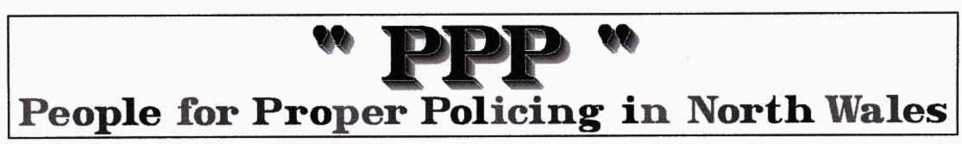
Updated motorcycle test videos on YouTube

The Driving Standards Agency ( www.dsa.gov.uk/ ) has updated two of its modular motorcycle test videos on YouTube.

If you run your own website and link to these videos, you'll need to update your site to make sure your customers can see them.

You can watch the updated versions using these links:

&&&&&&Official DSA motorcycle test (part 2 of 15) - waiting room

The official DSA step-by-step demonstration of the modular motorcycle test launched on 27 April 2009.

This link will give you access to all 15 parts of the DSA series of videos.

